Name: Mokgola Kholofelo
Student Number:st10482863
Website Overview
(step 3 n 4)
NoveTech IT Solutions

Table of Contents
- Website Sitemap………………………………………………………………………………. Page 3
- Proposed Website Sitemap
- Sitemap Explanation
- Low-Fidelity Wireframes……………………………………………………………………. Page 4-7
- Home page wireframe
- About us page wireframe
- Services page wireframe
- Portfolio page wireframe
- Contact us page wireframe
- Introduction (Website Overview) …………………………………………………………. Page 8-10
- Home Page
- About Us
- Service Page
- Portfolio Page
- Contact us page

1. Website Sitemap
A sitemap is a visual representation of the website structure. It shows how all the web pages are connected and helps ensure that users can navigate the website easily.
Proposed Website Sitemap
Home

About Us Services Portfolio Contact Us

Computer Repair Website Design Network Solutions Cyber Security
Sitemap Explanation
The Home page will act as the main entry point to the website. From the Home page, visitors can access the About Us, Services, Portfolio and Contact Us pages using the navigation menu.
The About Us page will provide information about the company, including its background, mission and vision.
The Services page will present the various IT services offered by TechNova IT Solutions. Some services, such as Computer Repair, Website Design, and Network Solutions, may have their own sections to provide more detailed information.
The Portfolio page will showcase completed projects and demonstrate the company's experience.
The Contact Us page will provide the company's contact details, business location, operating hours and a contact form that customers can use to submit enquiries or request quotations.

2. Low-Fidelity Wireframes
Low-fidelity wireframes are simple sketches used during the planning stage of website development. They focus on the placement of content rather than colours, fonts or images. Creating wireframes helps organise information before writing HTML code.
Home Page Wireframe
---------------------------------------------------------
COMPANY LOGO
---------------------------------------------------------
Home | About | Services | Portfolio | Contact
Welcome to TechNova IT Solutions
Short Introduction to the Company
[Learn More] [Get a Quote]
---------------------------------------------------------
Featured IT Services
---------------------------------------------------------
Customer Testimonials
---------------------------------------------------------
Footer
---------------------------------------------------------
Description
The Home page introduces visitors to the company and provides quick access to the most important information. It contains a navigation menu, a banner, a short company introduction, featured services, customer testimonials, and a footer with contact information.

About Us Page Wireframe
Home | About | Services | Portfolio | Contact
---------------------------------------------------------
About TechNova
---------------------------------------------------------
Company History
Mission Statement
Vision Statement
Company Values
---------------------------------------------------------
Footer
---------------------------------------------------------
Description
The About Us page provides visitors with information about the company's history, mission, vision, and values. This page helps establish trust and credibility.
Services Page Wireframe
Home | About | Services | Portfolio | Contact
---------------------------------------------------------
Our Services
---------------------------------------------------------
Computer Repairs
Website Development
Network Installation
Cybersecurity

---------------------------------------------------------
Footer
---------------------------------------------------------
Description
The Services page provides detailed information about each service offered by TechNova IT Solutions. Visitors can quickly understand the solutions available and determine which service best meets their needs.
Portfolio Page Wireframe
Home | About | Services | Portfolio | Contact
---------------------------------------------------------
Recent Projects
---------------------------------------------------------
Project Image
Project Description
Client Feedback
---------------------------------------------------------
Footer
---------------------------------------------------------
Description
The Portfolio page displays examples of completed work to demonstrate the company's experience and technical expertise. It helps build confidence among potential customers.
Contact Us Page Wireframe
Home | About | Services | Portfolio | Contact
---------------------------------------------------------
Contact Information
---------------------------------------------------------
Telephone Number
Email Address
Business Address
Contact Form
---------------------------------------------------------
Footer
---------------------------------------------------------
Description
The Contact Us page allows customers to communicate with the company by providing contact details, business hours, and an online enquiry form. It also includes a map to help customers locate the business easily.

Introduction (Website Overview)
This project focuses on the planning and development of a basic website for TechNova IT Solutions, an Information Technology company that provides reliable and innovative IT services. The purpose of the website is to establish an online presence, promote the company's services, and provide customers with easy access to important information and contact details. The website consists of multiple interconnected HTML pages, including the Home, About Us, Services, Portfolio, and Contact Us pages, each designed to provide a user-friendly browsing experience. This project demonstrates the application of HTML, website planning, content organisation, and navigation to create a functional and professional business website.
- Home Page
The Home page serves as the main landing page of the TechNova IT Solutions website. It introduces visitors to the company, highlights the services offered, and explains why customers should choose the business. The page also provides a clear navigation menu that allows users to access other pages easily. It is designed to create a positive first impression and encourage visitors to explore the website
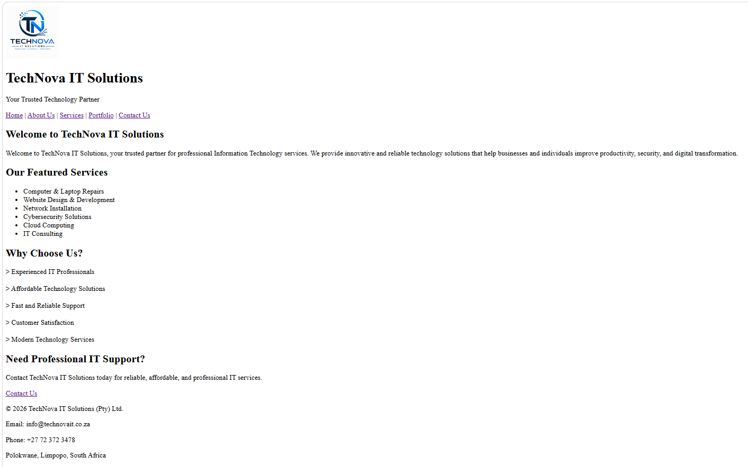

- About us
The About Us page provides information about TechNova IT Solutions and its background. It explains the company's mission, vision, and commitment to delivering reliable and affordable IT services. This page helps visitors understand the company's values and goals. It also builds trust by introducing the organisation and its purpose.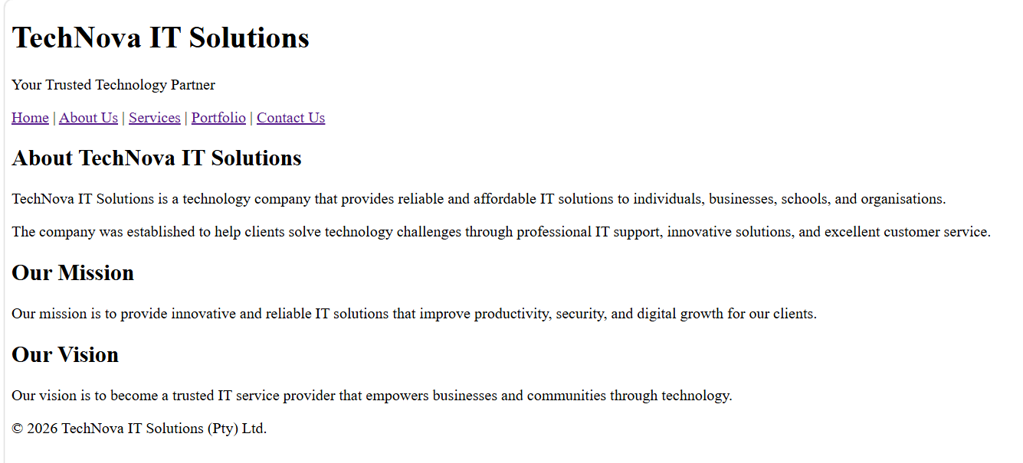
- Service Page
The About Us page provides information about TechNova IT Solutions and its background. It explains the company's mission, vision, and commitment to delivering reliable and affordable IT services. This page helps visitors understand the company's values and goals. It also builds trust by introducing the organisation and its purpose.
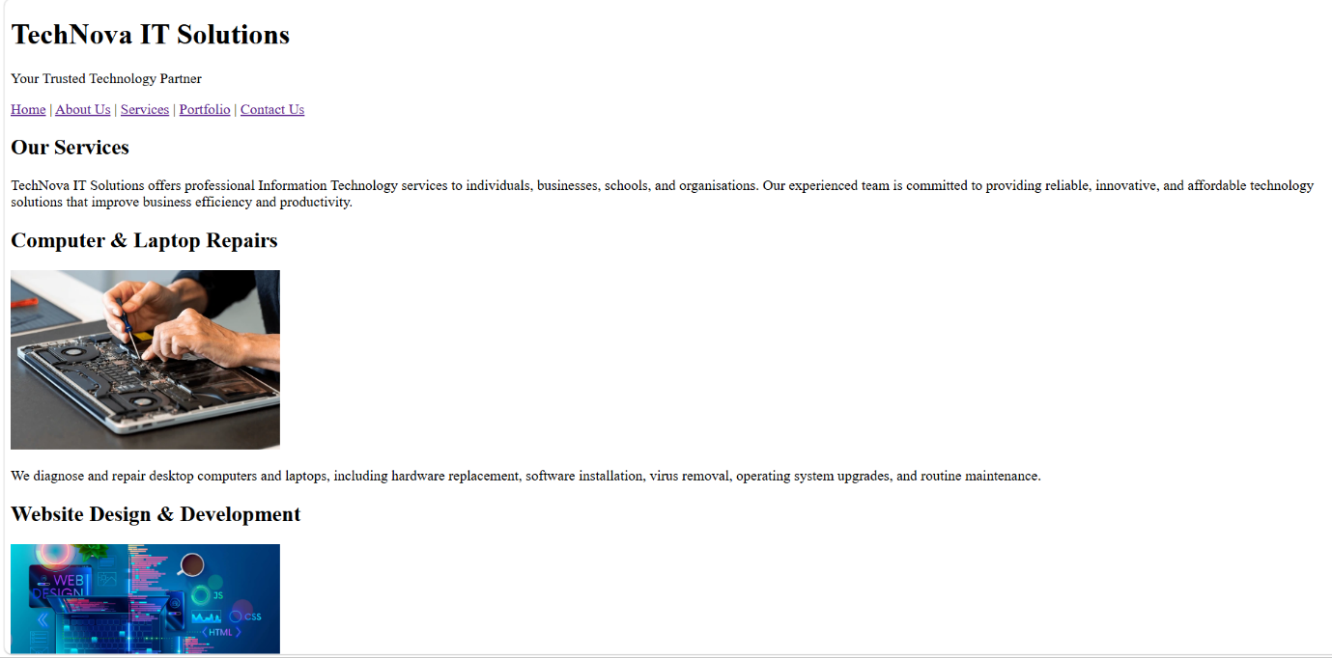

- Portfolio Page
The Portfolio page highlights completed projects and successful work carried out by TechNova IT Solutions. It demonstrates the company's experience through examples of website development, network installations, and computer support projects. This page helps build credibility by showing the quality of previous work. It also gives potential clients confidence in the company's capabilities.
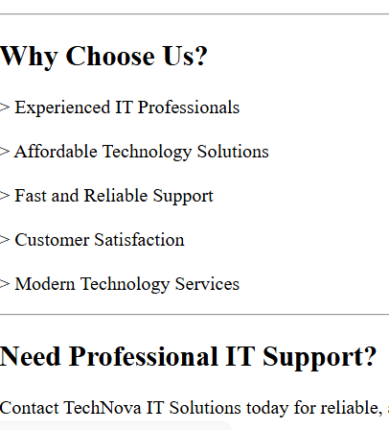

- Contact us Page
The Contact Us page provides visitors with the company's contact details, including the phone number, email address, business address, and operating hours. It also includes an enquiry form that allows users to send questions or request services directly from the website. The page makes it easy for potential clients to communicate with the company. It ensures that customers have multiple ways to get in touch for support or business enquiries.
